Outlook – Email Setup Guide

How do I configure email using Microsoft Outlook?
To setup Outlook to work with your Big Boy Media mail account please follow these instructions.

- Start Outlook and from the Tools menu, select ‘Accounts’

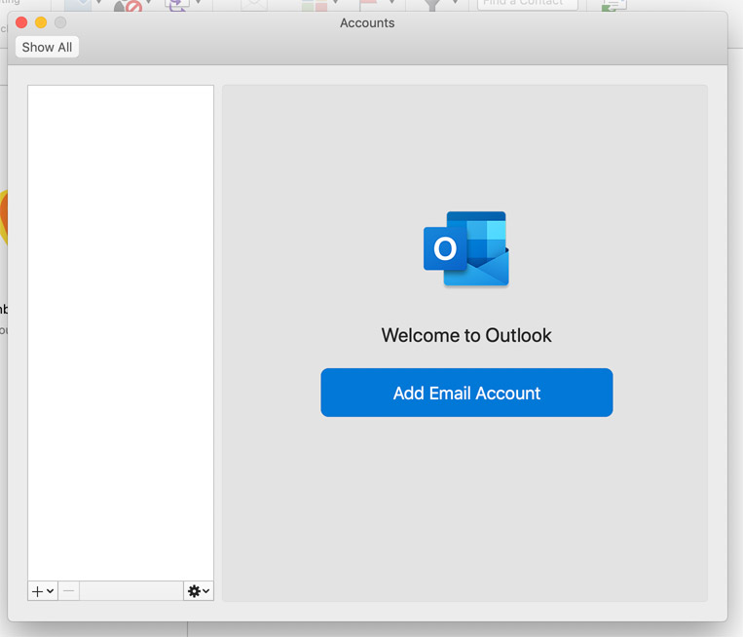

- The first time you access Outlook, you will need to click the big ‘Add New Account’ button, or if you already have accounts set up, you can click on the + icon to add a new email account to your PC or Mac.

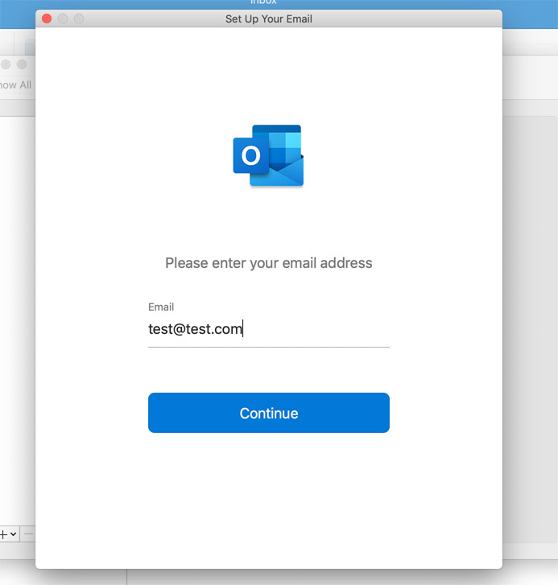

- Add the email address associated with your account, and click the ‘Continue’ button. It will test to see if the domain name is Gmail or something similar, but as your email will be on a custom domain you need to wait or select ‘Choose the Provider’.
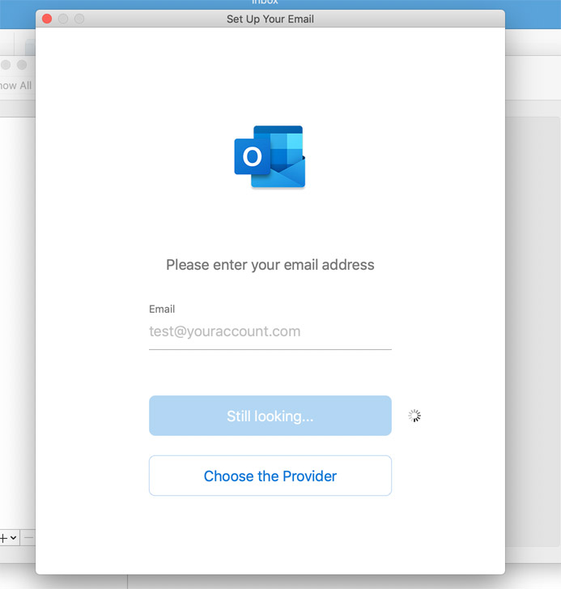

- From the options on the next screen, select IMAP/POP.

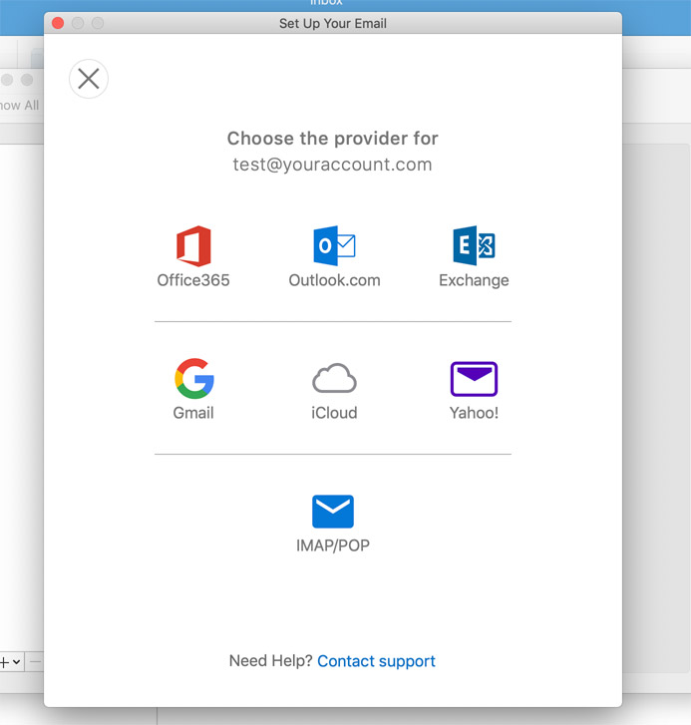

- The next step is to enter all your mailbox settings. You can select to use either an IMAP or a POP account.

IMAP is best for phones or tablets to check email on the move, but POP is needed for your office computer to permanently pull emails from the server so it doesn’t fill up your mailbox as there is just a finite space on there.
See screenshot below for sample settings.
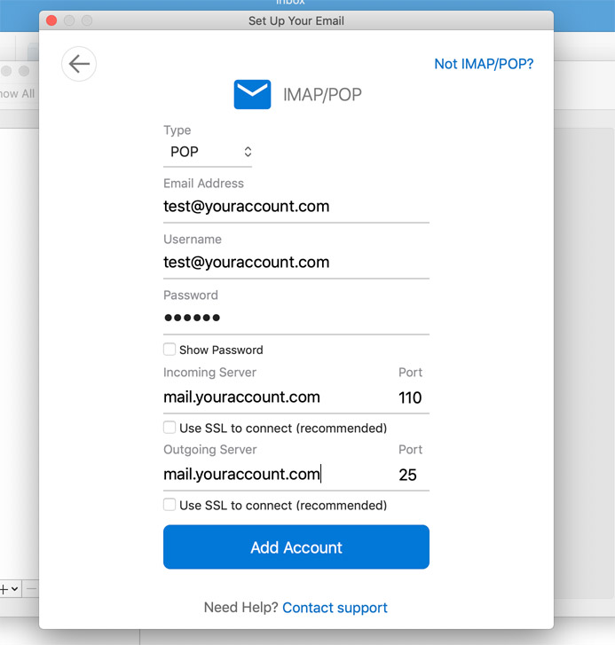

- So after selecting POP, your settings should be similar to those in the screenshot above, but tailored to your email address and your domain name.

For example:
Email Address -> the email address you want to add
Username -> (same as above)
Password -> password for your email address
Incoming server is -> mail.’insert your domain name’ (so if your email address was info@bigboymedia.com, then your incoming mail server is mail.bigboymedia.com)
Outgoing server -> same as above
You then also need to uncheck the ‘use SSL to connect’ two checkboxes for POP, but IMAP they can usually be left ticked.
In new versions of Outlook you usually have a default setting set for ‘my server requires authentication’ (not in screengrab) that needs to be selected too.

- Click the Add Account button, and this will verify that all your info is correct.

You will have the option to also set your name as people who receive your email will see in the sender field, eg ‘Jordan Taylor – Big Boy Media’.

And that’s it! Your email account will now be added to your PC or Mac.

